Part 3:

Functions: World (Big-bang options)

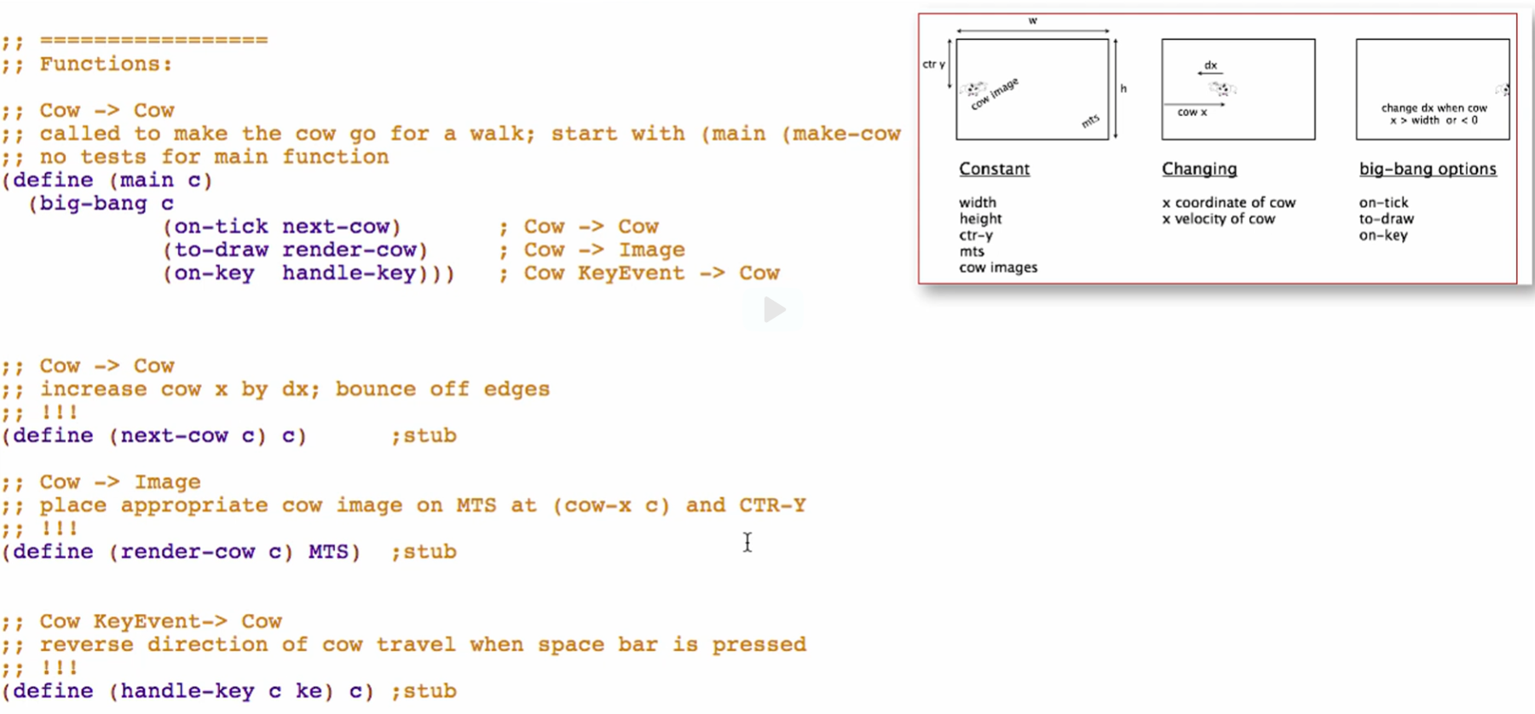

Working through the wish lists

1. next-cow

**Signature, purpose, and stub**

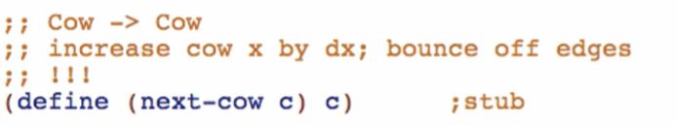

**Examples**

Middle cases:



Before edge cases:



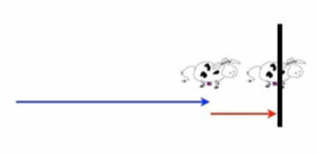



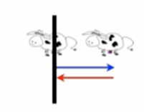



At the edge (bouncing off)



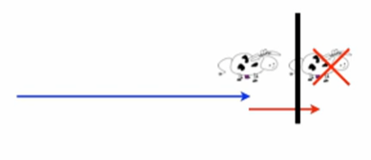 

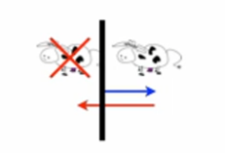



Check if well formed

**Template**

Rename function

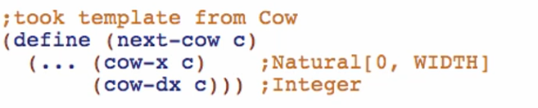

3 case cond:

* middle & reaches edge (normal) (1 cond)
* tries to pass edge (change direction)
  + left edge (1 cond)
  + right edge (1 cond)

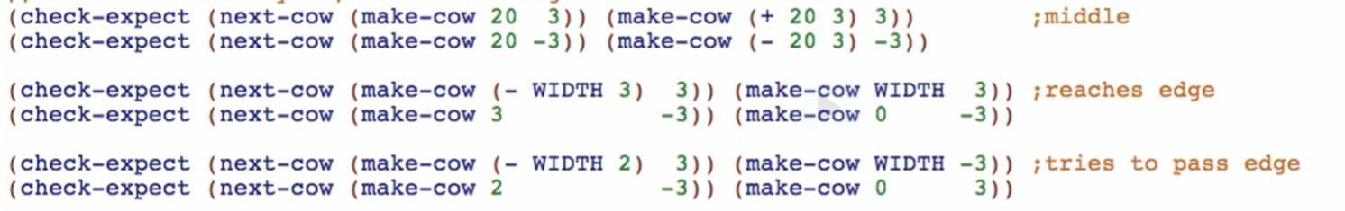

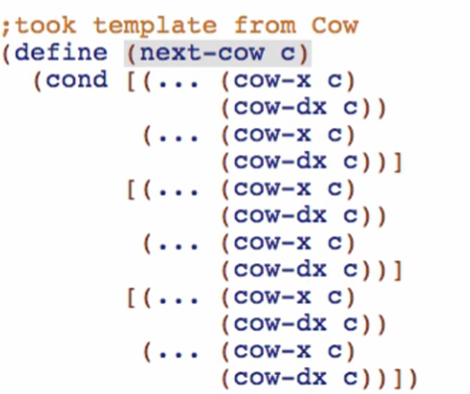

**Code body**

First condition (tries to pass right edge): change velocity when cow’s position is > width

* start position again at WIDTH
* negate velocity

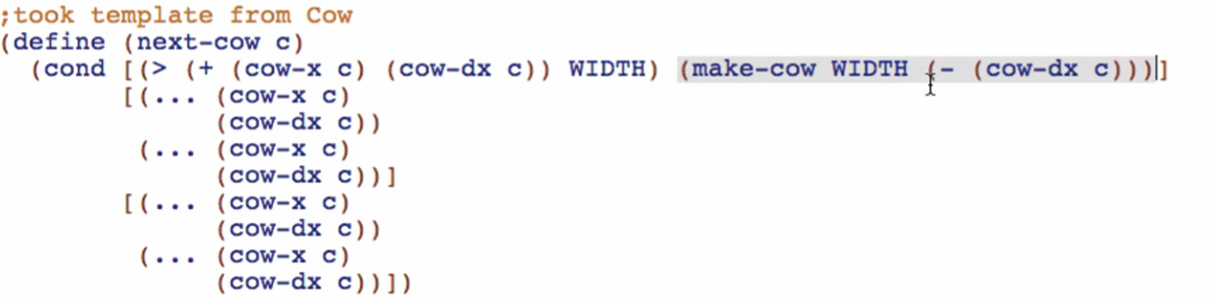

Second condition (tries to pass left edge): change velocity when cow’s position is < 0

* start position again at 0
* negate velocity

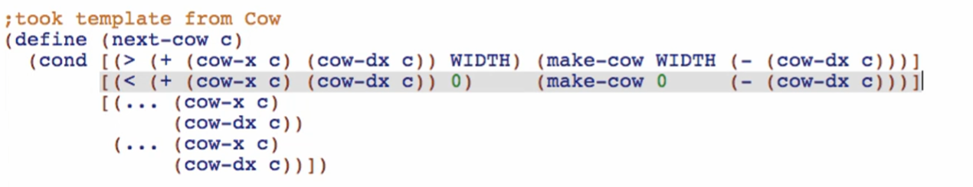

Third condition (normal): no changing of velocity

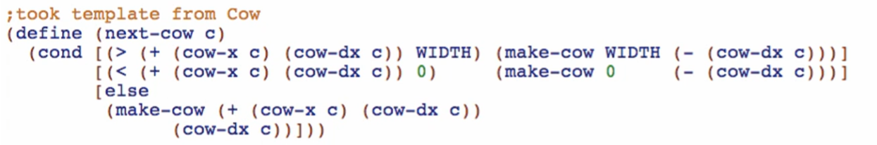

Check if passing